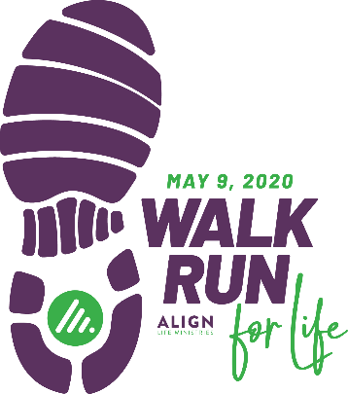

The Power of Personalization
5 Tips to Personalize Your FundEasy Page
- Edit or Update your Page Title: Change the title from “Walk Run for Life” to “Walk with me for LIFE!” or “Champion the GOSPEL & LIFE with me!” etc. Tap into your creativity to make a unique call to action at the top of your fundraising page.
- Edit Profile and Social Sharing Settings: Here is where you can edit your personal information like name and profile photo, as well as adjust the social sharing settings for automatic emails and tweets.
- Edit and Update your Goal: Change your fundraising goal amount to the one YOU want to achieve!
- Photos or Video: Upload a photo of yourself, photos that pertain to Align Life Ministries and/or the Walk Run, or photos of you and your “team” to create an instant personal connection from you to Align Life Ministries. Or record a short, personal video straight from your heart as to why you are involved. If you can gather the courage to hop in front of your smartphone and press record…then do it! Trust us, people want to hear from YOU.
- Write a Compelling Welcome Message: Your welcome message is one of the most important parts of personalizing your FundEasy page.

3 Quick Tips for Writing Your Welcome Message
- Share why YOU care. Why are you involved with the Walk Run for Life? Is there a connection to your personal story or testimony? Do you have a volunteer experience? Have you had an experience that you are willing to share with your supporters (for example, perhaps related to an unintended pregnancy, adoption, or abortion) to convey your passion for life? Simply sharing from your heart about your genuine connection with Align Life Ministries is an awesome way to appeal to others and invite them into the joy of supporting the AMAZING work God is doing through Align Life Ministries. They can either join your team or sponsor you.
- Share a compelling fact or statistic about Align Life Ministries. For example, in 2019 103 decisions to carry reinforced via ultrasound, and 219 men enrolled in ministry services. Facts like these are sprinkled throughout our Align Life Ministry Facebook page.
- Link to a compelling testimony or success story from an individual or couple that Align Life Ministries has served. There is nothing quite so powerful as seeing the story of someone whose life has been transformed! Check out our YouTube page for videos to share. https://www.youtube.com/results?search_query=SVPSinPA

