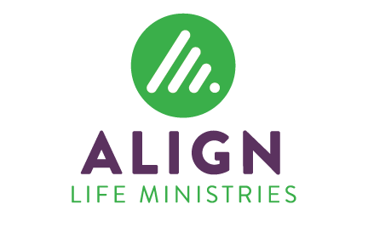

Align Life Ministries is a gospel-sharing, life-affirming ministry with client locations in Lancaster and Lebanon counties. For more information go to alignlifeministries.org.
ALIGN PREGNANCY SERVICES DIRECTOR – LEBANON
(FULL-TIME)

Align Life Ministries is seeking a Director to oversee client services at our Lebanon location. This position requires a mature individual with strong interpersonal skills and a desire to compassionately share the gospel of Jesus and reach out to abortion-minded women. A self-starter with experience in direct client care, volunteer recruitment, and management is essential. Spanish-speaking preferred but not required. Forty hours per week, including regularly scheduled evenings; occasional speaking engagements on weekends. Compensation is in line with a local non-profit organization of similar size.
All applicants must be in agreement with Align Life Ministries’ Statement of Faith; Statement on the Sacredness of Human Life; Statement on Biblical Authority; and Statement on Marriage, Gender, and Sexuality.
If interested, send a resume and cover letter as soon as possible to: Align Life Ministries, P.O. Box 707, Lebanon, PA 17042-0707, Attn: Mary Anna Wingenroth 717.274.5128 x 307 or mwingenroth@alignlifeministries.org

